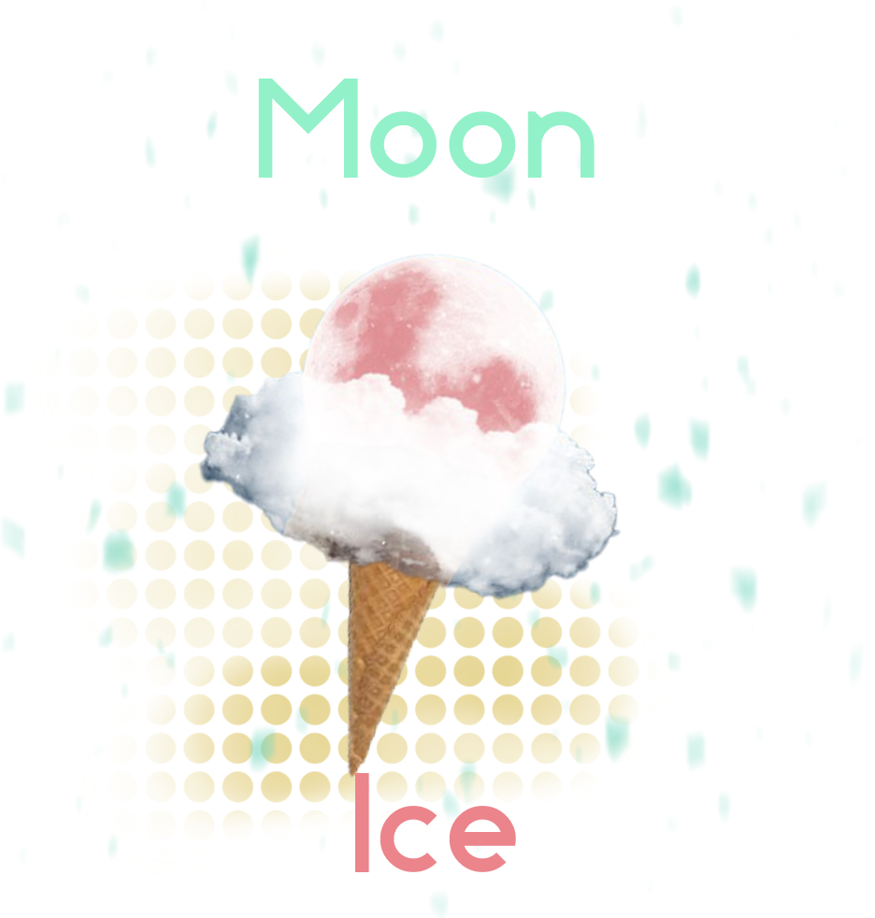

Moon Ice

Flavor Brochure

**Featured Space Ice flavors:**

1st release: Moon Dirt - vanilla bean iced cream with coconut flakes, butterscotch swirls, and chocolate covered walnuts.

2nd Release: Space Candy - cotton candy flavored iced cream in a neon green to hot blue tie dye color.

3rd Release: Moon Rocks - Chocolate iced cream with marshmallows and chocolate covered almond chunks.

4th release: Wookie dough - cookie dough with chocolate iced cream

5th release: Solar Sunburst - Tutti Fruity flavored iced cream.

6th release: Space Matter - cake batter flavored iced cream

**Standard Flavors**

Dark Side of the Moon(Chocolate)

Light Side of Moon(Vanilla)

Moon Glow(French Vanilla)

Cosmic Cream(Cookies & Cream)

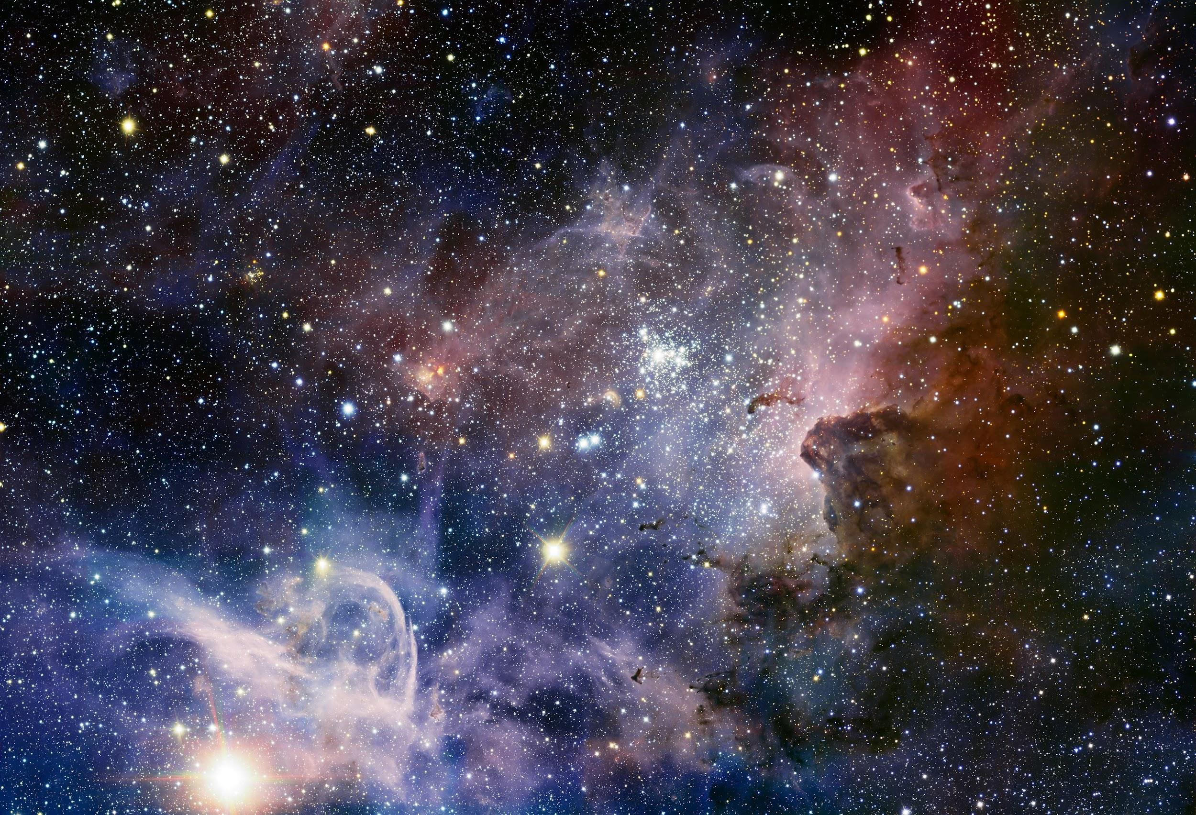

*Colorful Nebula*

# The Concept

- - - - X

The future is here! Why shouldn’t astronauts and visitors alike enjoy the luxuries of home! Those nostalgic enough to remember dried space iced cream can again enjoy it. Those that prefer the delectable gourmet ice cold cream are in luck, even on the moon! Moon ice will be the first ever ice cream parlor on the moon. The timing is perfect now that so many civilians are visiting space.

“

Delectable Gourmet Ice Cold Cream

-Elon Musk

”

# Taste the Yum. Placeholder image

- - - - X

Enjoy the wonderful view through our outdoor crystal clear private bubbles.

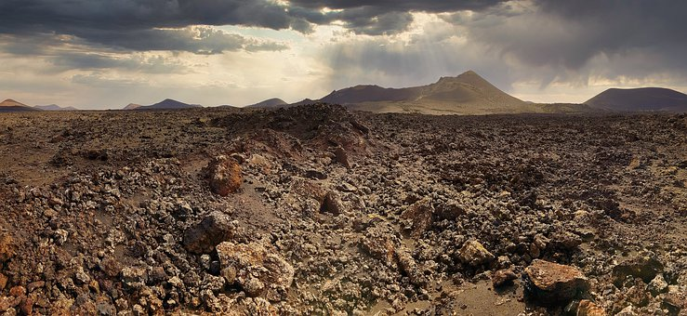

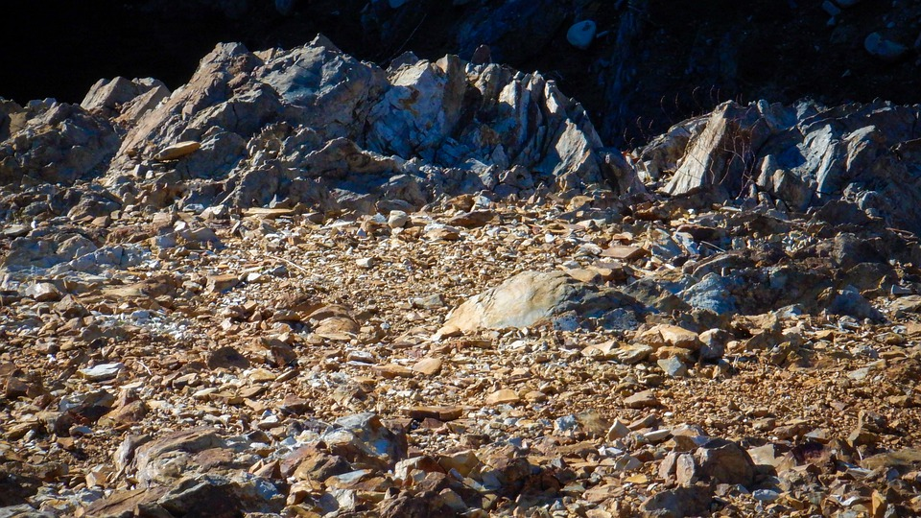

*Moon Rocks*